[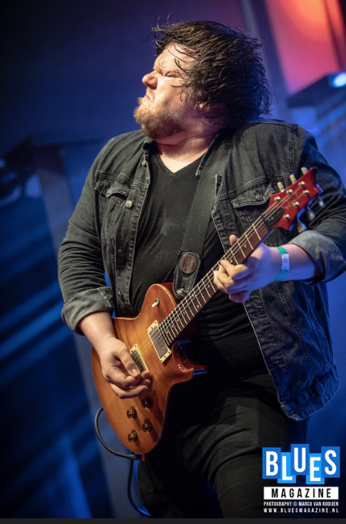](https://www.youtube.com/watch?v=J2nA1qfzAZ4)

*'Catfish are one of the finest live bands in Britain today.  The quality of musicianship is outstanding and in Matt Long, they have one of the greatest young guitarists on the scene today...' Blues Matters Magazine.*

UK and British Blues Award winners

[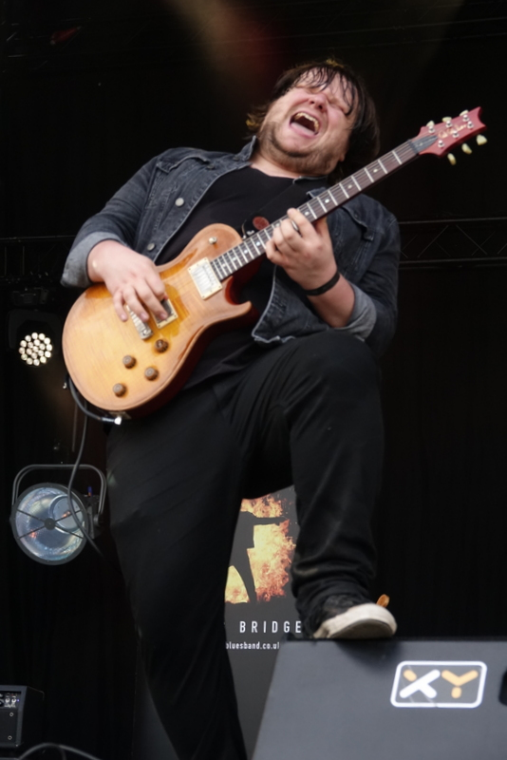](https://www.youtube.com/watch?v=QpgIKKdRllM)

In the last few years, they have played at almost every major UK blues festival and have established themselves as a real force in the British blues scene. They are now being approached by the European festivals, having already played at Swing Wespelaar (BE) and Sinnflut (DE) in 2018, Stekene (BE), Zyfflich (DE), Le Buis (FR) and recently Sumperk (CZ) in 2019.

International touring blues rock powerhouse Catfish have been making waves on the music scene in the UK and Europe, winning the UK Blues Award in 2018 as Blues Act of the Year (England). Their album Broken Man was named album of the year by the Independent Blues Broadcasters Association and was also nominated for a UK Blues Award. They had previously won a British Blues Award in 2016 and been nominated for four others over two years.

https://www.youtube.com/watch?v=vFzpgXwfFac[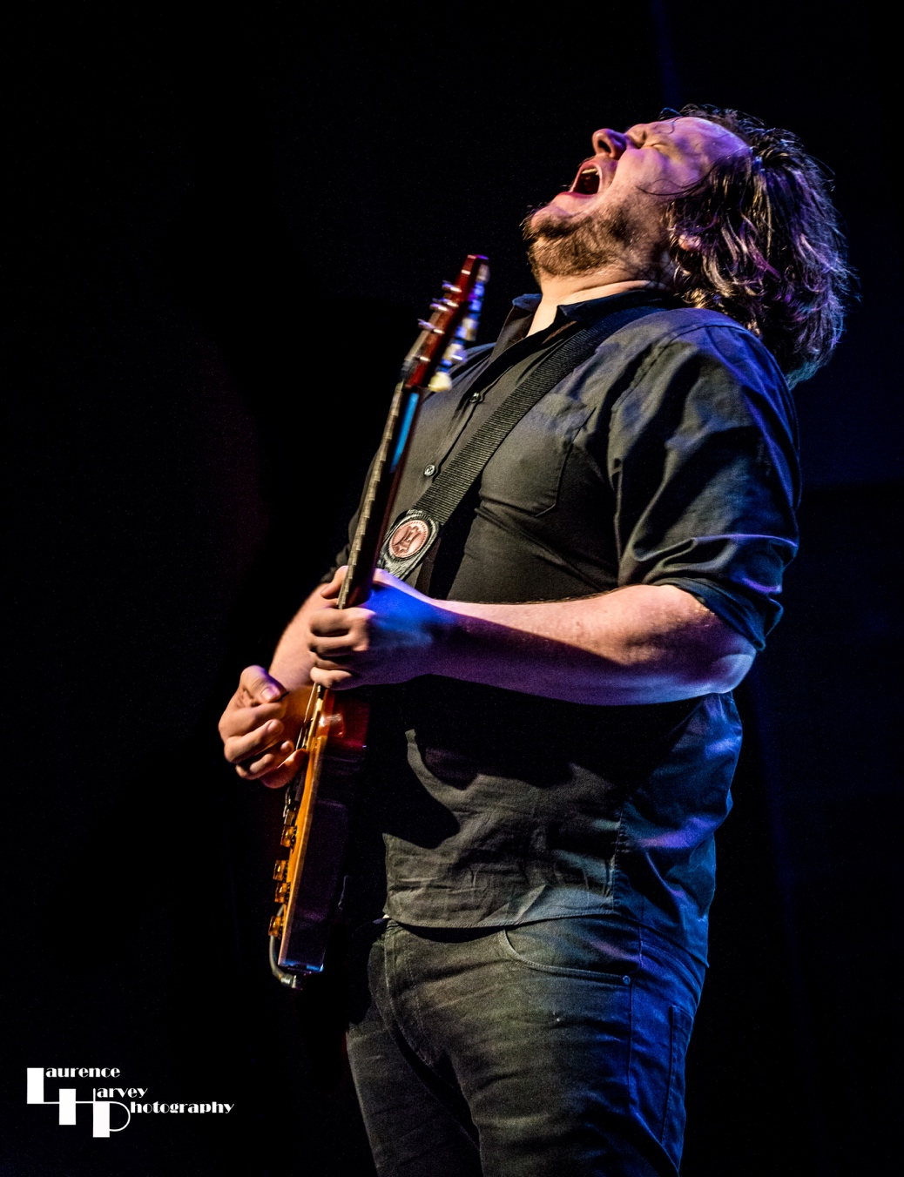](https://www.youtube.com/watch?v=vFzpgXwfFac)[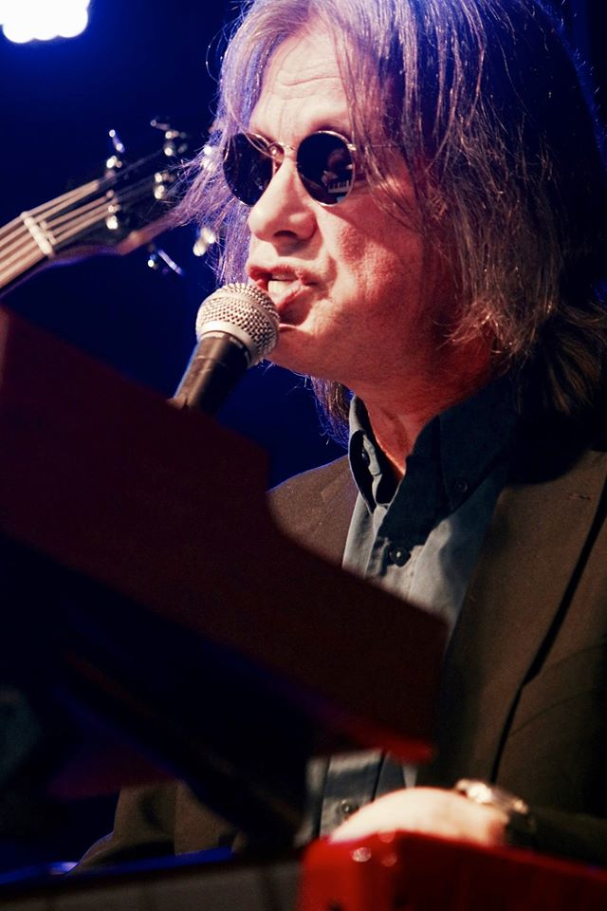](https://www.youtube.com/watch?v=1WCACgy7J_4)[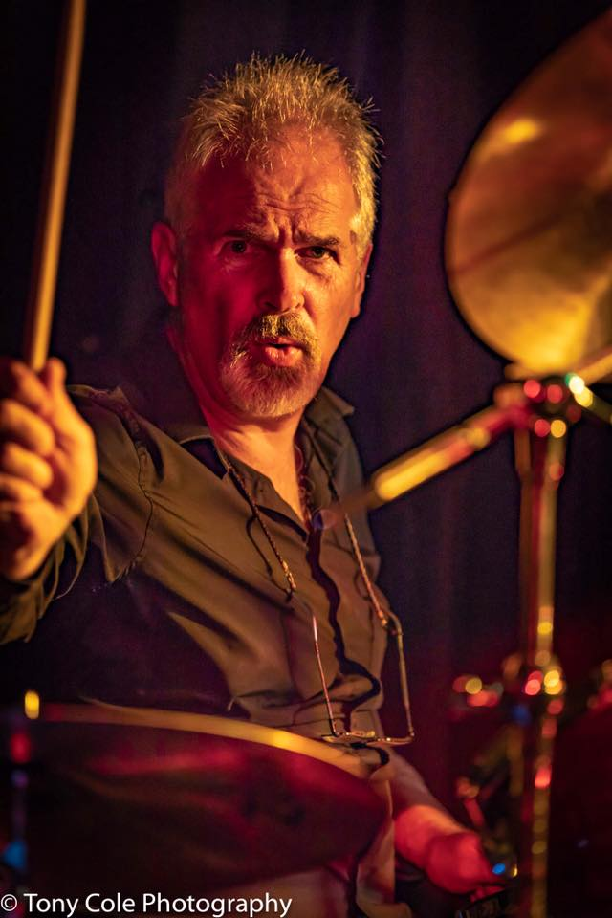](https://www.youtube.com/watch?v=FHssz4TaUQk)[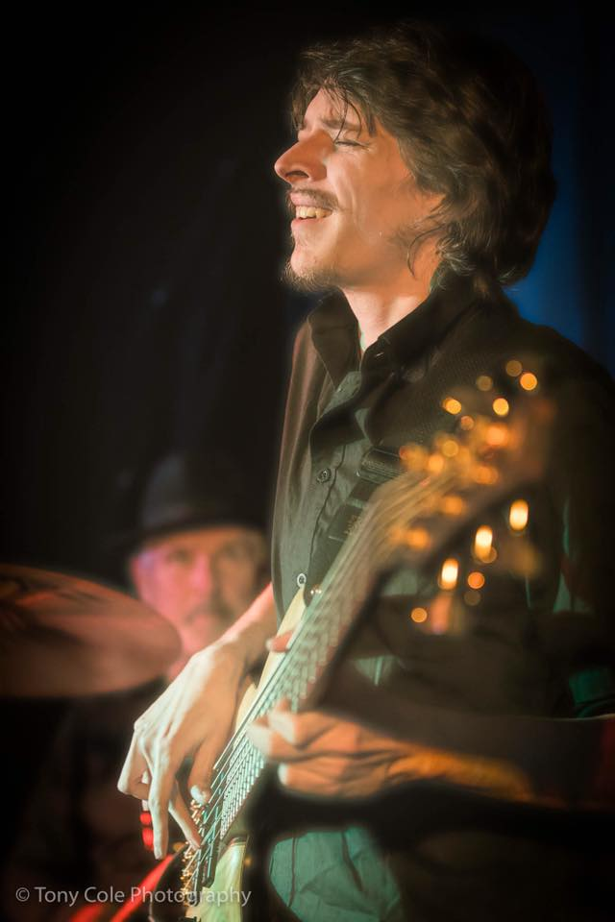](https://www.youtube.com/watch?v=0gQVYypF-eA)

**Matt Long - guitar**

Matt was raised on blues, but his other influences are many and varied. His rock and metal bands started at ACM and their legacy remains in many of the songs on the new album. His evocative, raw and honest song-writing features on many of the songs on both Broken Man and Burning Bridges.

**Paul Long – keyboards and vocals**

Paul Long, father of Matt, is also one of the songwriters on both Broken Man and Burning Bridges. He also recorded and produced all three albums and has his own radio show on Blues and Roots Radio.

**Kevin Yates – drums**

Kevin met Matt and Paul at the blues jams on the south coast. He brings a delicate subtlety to the ballads but strength and imaginative skills to the new rockier numbers.

**Adam Pyke – bass**

Adam and Matt met at the Academy of Contemporary Music (ACM) in Guildford and have been firm friends ever since. Adam’s influences are many and varied, and he has added a dark, menacing sub- layer to many of the songs with his six-string bass. He also writes, and his song Under the Gun features on the Burning Bridges album.

MEET THE BAND

[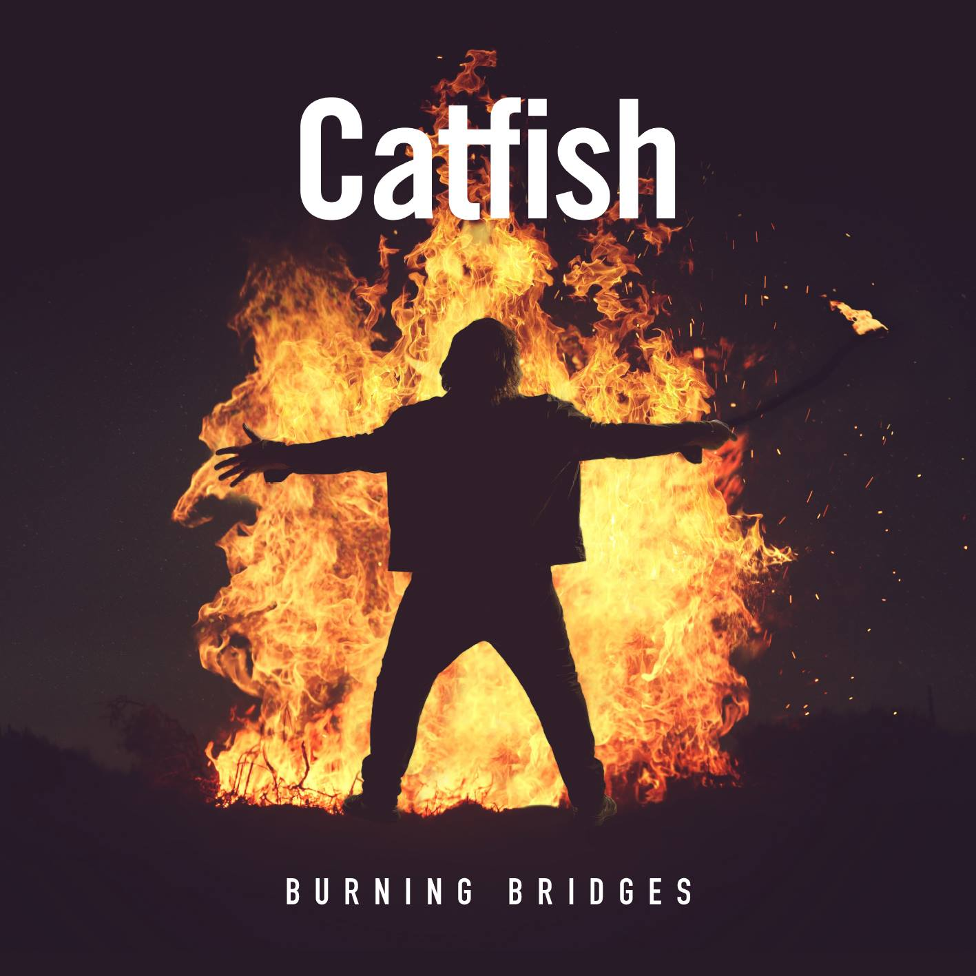](https://www.youtube.com/watch?v=FSgw6fNX4D8)

Their third album, Burning Bridges, was released on 7 May 2019, a collection of excellent and diverse songs, many autobiographical, and which both musically and lyrically are pushing new boundaries for the band. Most of the songs, as on the previous album ‘Broken Man’, are written by guitarist and vocalist Matt Long and keyboard player/vocalist Paul Long.

However, this is deliberately no ‘Broken Man 2’. On ‘Burning Bridges’, Matt and new bass player Adam Pyke’s rock influences are very apparent, both in many of Matt’s self-penned songs and one (Under the Gun) which is a co-write between Adam and Matt. Paul’s more lyrical influence is apparent in his own songs including the beautiful piano ballad ‘One More Chance’ and the atmospheric ‘Ghosts’ which continues to give the band’s live shows variety and range.

**Reviews from the blues press for ‘Burning Bridges’**

‘Catfish exudes quality and phenomenal how a young guitarist can play the blues like this.’   
  
Maxazine.nl

[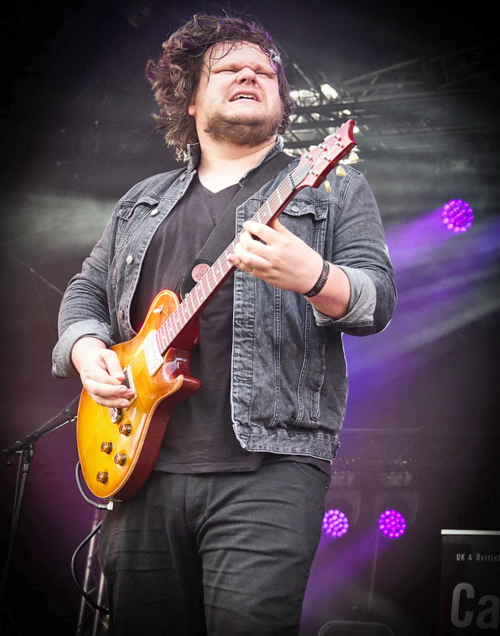](https://www.youtube.com/watch?v=B3HafMlctyQ)

‘A veritable feast of powerful, sensitive, rocky, soulful and lyrically mature songs that are an assault on one’s musical senses in a great way…This is an album that says confidently and clearly that Catfish are not just another Blues/Rock outfit joining the party. They are a band committed to great songs, thoughtful lyrics, first-rate musicianship. This album is, for me, a bold statement about the band’s intention to not compromise when it comes to providing the listener with an album that cuts no corners.’

Keith Baldwin, midlandsmetalheads.com

‘The strong buzz that has been going around about this new album and proclaiming Catfish as one of the hottest bands of the decade aren’t wrong: the writing, playing and sheer balls0out power of this band is remarkable…it is such a joy to hear a relatively new band who are as talented and convincing as Catfish’

Andy Snipper, MusicNews.com

‘This is another brilliant album by the band and I’m sure it won’t be long before Burning Bridges will also be mentioned at the awards ceremonies.’   
  
Dave Martin, Jace Media

‘With their 3rd studio album, these Catfish assure themselves of a place in the British rock firmament.’

Rootsville.eu, Holland

[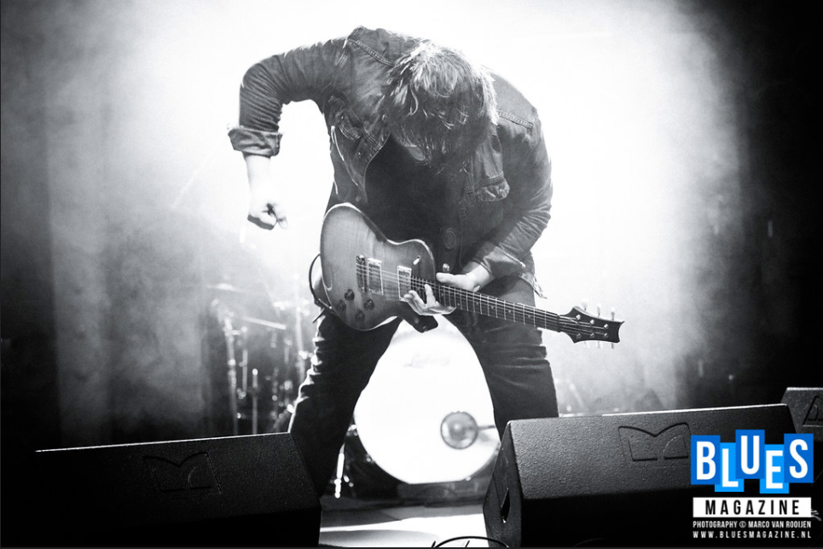](https://www.youtube.com/watch?v=bjTzJ6GijIw)

CONTACTS

To book the band in Germany and Belgium, please contact Dani Vazzoler of Good Time Promotions on [dani@goodtimebooking.com](mailto:dani@goodtimebooking.com)

For Holland contact Kees Spruit at Monkeyman at

[info@monkeyman.nl](mailto:info@monkeyman.nl)

For France contact Laurent Bourdier

[bourdier.l@wanadoo.fr](mailto:bourdier.l@wanadoo.fr)

For Czech Republic contact Jiri Sveda on

[sveda.art@seznam.cz](mailto:sveda.art@seznam.cz)

For UK and all other locations please contact Fiona Long on

[info@catfishbluesband.co.uk](mailto:info@catfishbluesband.co.uk)

[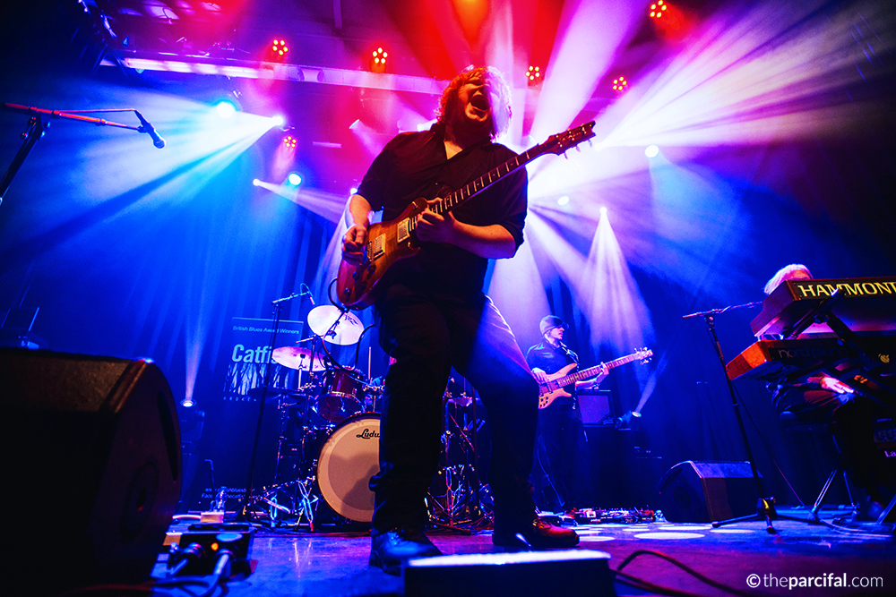](https://www.youtube.com/watch?v=P8YPSfcrDdc)[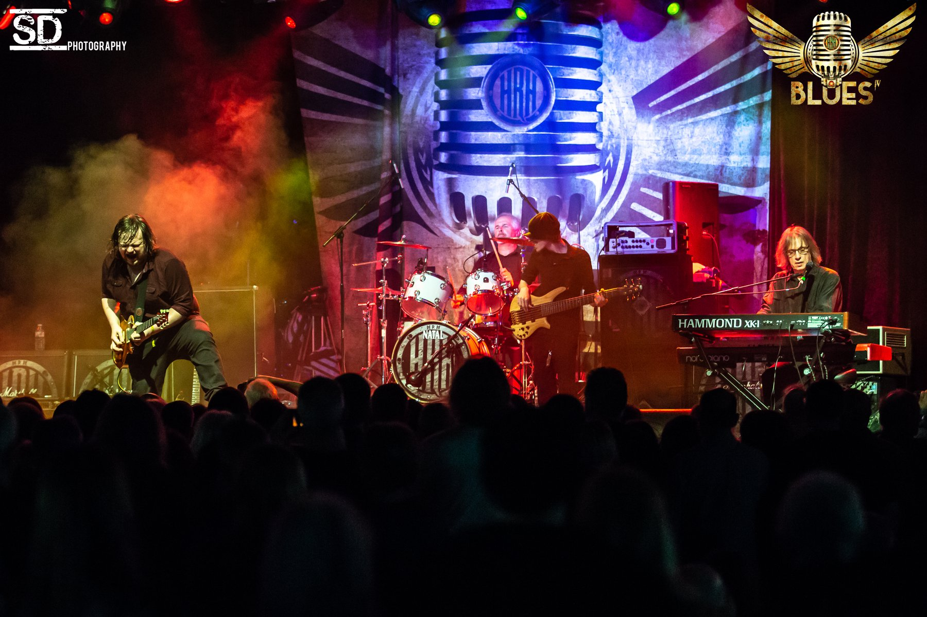](https://www.youtube.com/watch?v=nUxtOL_JZRw)

**LIVE PERFORMANCE VIDEOS**

Click on any of the images above in this EPK to hear tracks from the new album ‘Burning Bridges’ or the previous album ‘Broken Man’ or to see the band’s live performance click on the photos on this page.

For more information please contact [info@catfishbluesband.co.uk](mailto:info@catfishbluesband.co.uk)

Website

[www.catfishbluesband.co.uk](http://www.catfishbluesband.co.uk)